

STOCK PRICE PREDICTION USING MACHINE LEARNING

First Progress Report

Bachelor of Technology
In
Computer Science Engineering

Project Suprevisor- Ms. Tanvi

Submitted By
PRIYANKA-04315602718
PRIYANSH GUPTA-04415602718

DEPARTMENT OF COMPUTER SCIENCE & ENGINEERING
Dr. AKHILESH DAS GUPTA INSTITUTE OF TECHNOLOGY & MANAGEMENT
(AFFILIATED TO GURU GOBIND SINGH INDRAPRASTHA UNIVERSITY, DELHI)
NEW DELHI – 110053
Objective

This project is divided into 2 parts, a research component and an application component, aiming to provide investors with stock price predictions using different machine learning models in a good user experience way for reference.

This project will investigate how different machine learning techniques can be used and will affect the accuracy of stock price predictions. Different models, from linear regression to dense and recurrent neural networks are tested. Different hyperparameters are also tuned for better performance.

Design

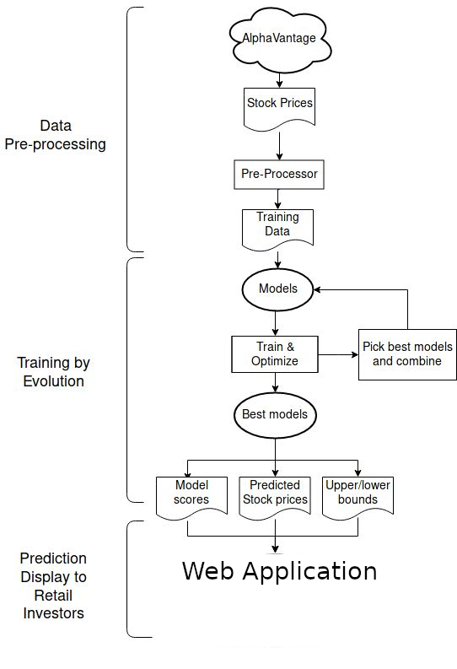

Model Working

We have used various machine learning algorithms to see which one works the best for predicting the results. Till now the best working model is of LSTM(Long Short Term Memory).
It is an recurrent neural network architecture used in the field of deep learning. LSTM networks are well-suited to c;assifying, processing and making predictions based on time series data, since there can be lags of unknown duration between important events in a time series. LSTMs were developed to deal with the vanishing gradient problems that can be encountered when training traditional RNNs.

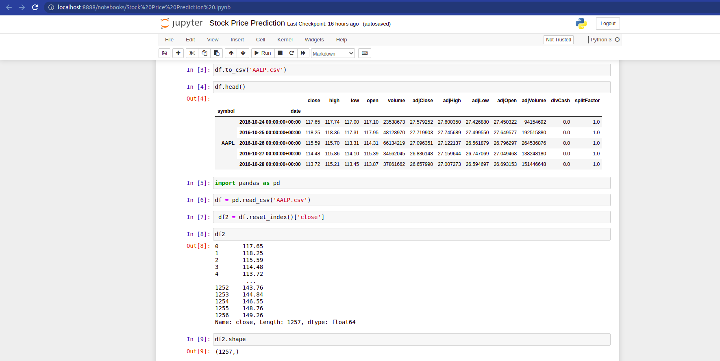
Importing Data

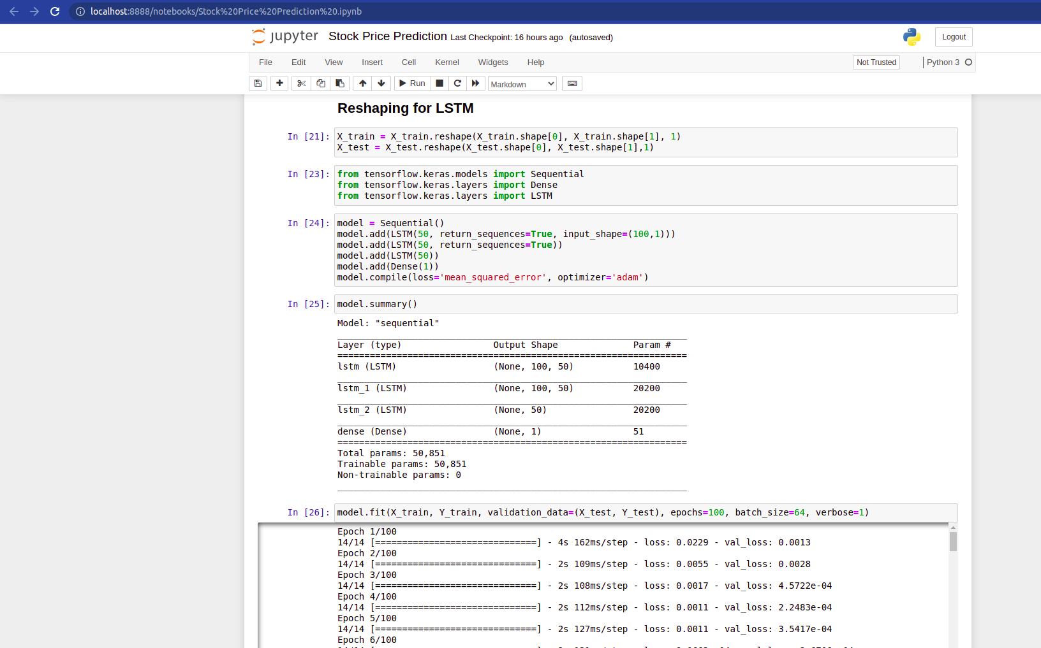
Using Uni-directional LSTM

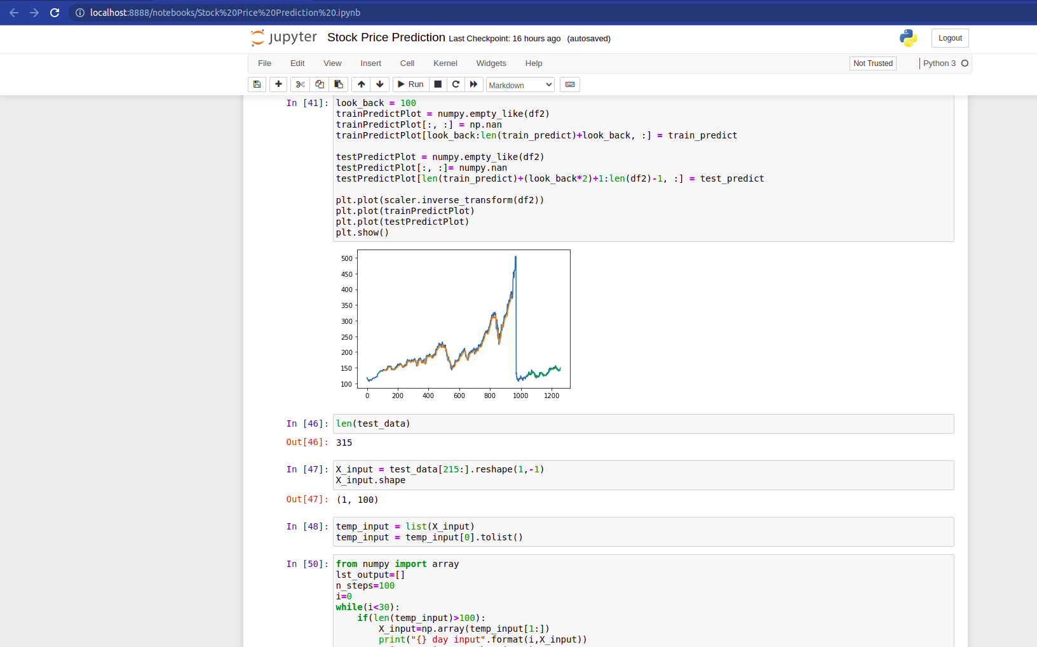
Plotting the result

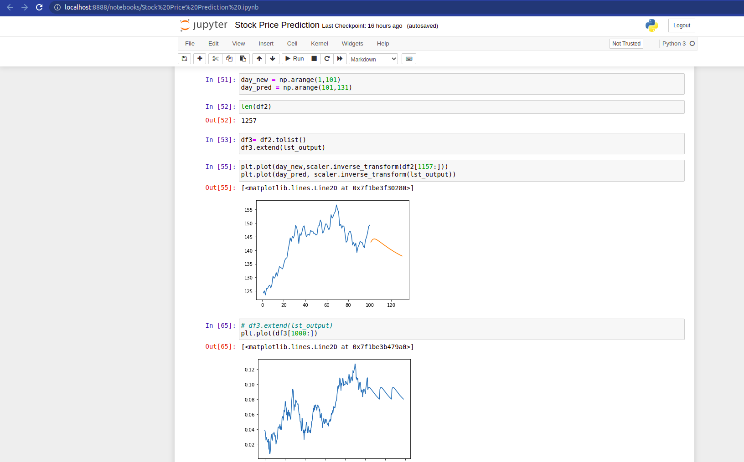
Plotting the next 30 days predictions

Remaining Work

Right now we are on improving the results by using bi-directional LSTM.
After that, the model deployment will be done, so that the users can easily assess the application.
The remaining work will be completed by first week of November.

References

[1] Stock Price Forecasting on Telecommunication Sector Companies in Indonesia Stock Exchange Using Machine Learning Algorithms
by- Jimmy H. Moedjahedy, Reymon Rotikan, Wien Fitrian Roshandi, Joe Yuan Mambu
2020 2nd International Conference on Cybernetics and Intelligent System (ICORIS)
URL- https://ieeexplore.ieee.org/document/9320758

[2] A time series analysis-based stock price prediction using machine learning and deep learning models
by- Sidra Mehtab, Jaydip Sen
URL- https://www.inderscienceonline.com/doi/abs/10.1504/IJBFMI.2020.115691

[3] Stock Market Analysis using Supervised Machine Learning
by- Kunal Pahwa, Neha Agarwal
2019 International Conference on Machine Learning, Big Data, Cloud and Parallel Computing (COMITCon)
URL- https://ieeexplore.ieee.org/document/8862225

[4] Stock Market Prediction based on Social Sentiments using Machine Learning
by- Tejas Mankar, Tushar Hotchandani, Manish Madhwani, Akshay Chidrawar, C.S Lifna
2018 International Conference on Smart City and Emerging Technology (ICSCET)
URL- https://ieeexplore.ieee.org/document/8537242

[5] Stock Index Prediction Based on Principal Component Analysis and Machine Learning
by- Shitao Zhu, Ming Zhao, Shengqing Wei, Simeng An
2020 International Conference on Big Data & Artificial Intelligence & Software Engineering (ICBASE)
URL- https://ieeexplore.ieee.org/document/9403775

